# Diabetes Classification Results using SVC

## Classification Report:

precision recall f1-score support  
  
 0 0.72 0.71 0.71 153  
 1 0.70 0.71 0.71 147  
  
 accuracy 0.71 300  
 macro avg 0.71 0.71 0.71 300  
weighted avg 0.71 0.71 0.71 300

## ROC AUC Score:

ROC AUC Score (SVC): 0.8205282112845137

## ROC Curve:

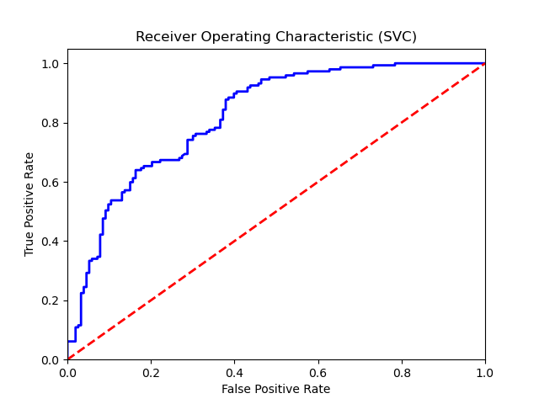

## Confusion Matrix:

True Negatives: 109

False Positives: 44

False Negatives: 43

True Positives: 104

## Confusion Matrix Plot:

